

**Amity University Madhya Pradesh**

10 **April** 2022

Emotion Recognition By The Help Of Supervised Learning

**Harsh Dubey**

*UG Student at Amity University Madhya Pradesh*

- - ***- - -- - -

**ABSTRACT---** Facial expression recognition is a subset of facial recognition that is becoming increasingly important as the need for it grows. Though there are ways for identifying expressions using machine learning and deep learning, this study seeks to detect expressions and categorise them based on photographs using deep learning and image classification. This study describes how various datasets are studied and analysed for training expression recognition models. With Kaggle, Inception Net is utilised for expression recognition (Facial Expression Recognition Challenge).

**Key words** — Facial recognition; expression recognition; deep learning; image recognition; Facial technology; signal processing; image classification

1. **INTRODUCTION**

Recognizing human expressions is a challenging endeavour that is also incredibly entertaining. Many data scientists are now striving to develop and teach robots to understand other people's sentiments or emotions.[1]

There are several techniques to test the identification of human expressions, including facial expressions, body posture, voice tone, and so on. In this study, we focused on facial expression detection and created a model that uses algorithms to predict the emotion of an image.[2] Nowadays, machine and human connection is rising because we prefer machine to human interaction, such as robots in the home, office, restaurant, and factory. As a result, our robot must be that develop to the point where they can learn on their own and identify facial expressions in order to

operate properly. In this research study, we concentrated on building a model, preparing data, and applying all of the algorithms to it to forecast the outcome. [3]

1. **LITERATURE REVIEW**

A comprehensive study on face emotion recognition is described in which the dataset attributes, facial emotion recognition study classifier are exposed.[4] Visual picture characteristics are analysed, and various classifier algorithms are described, which aids in the future examination of emotion identification systems. Using several classes of classifiers, this work investigated the prediction of future reactions from pictures based on emotion recognition. Some classification algorithms, such as K-Nearest Neighbor and Random Forest, are used to classify emotions. The use of neural networks to tackle challenges in data science is becoming increasingly popular.[5] Facial emotion recognition is gaining prominence in the scientific sector. Facial emotion recognition is examined and studied throughout all scientific domains.[6] This research investigates several databases used for face emotion detection, features extracted from facial expression photos, and classifiers used to categorise various types of emotions. Hidden markov models and deep belief networks were used to distinguish emotion from facial expressions, yielding an unweighted average recall (UAR) of roughly 56.36 percent ().[7] Using several classifiers such as KNN, HMM, GMM, and SVM, different picture kinds and emotions were investigated for recognising expressions from face expressions. This study discusses major feature learning techniques such as support vector machine training, local invariant feature learning, and salient discriminative feature analysis for face recognition. [8]

# data set:





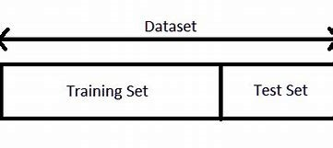

Our data collection contains a vast quantity of information in the form of photographs. These photos are quite little in size, yet they all contribute to the model's construction since they teach the machine how to appear joyful and sad.some example of images like.

* 1. **Preprocessing of the Dataset.**

# importing library:

To begin, we will import certain libraries such as NUMPY, Pandas, Seaborn, matplolib, nltk, warning, skimage.transform, and others that will assist us in building the mode and generating predictions. [9]

# defining category:

In this, we will define the category, such as happy or sad, and then begin a loop that will ask for picture input and then display the prediction result.

# LOADING IMAGE

Following the definition of the category, we will merge the paths of all images into a single path and then load the images into the dataset, after which we will resize all of the images.[10] Resizing is vital since we can't offer a huge image to a computer for training; instead, we must scale the image into little categories.[11] For prediction purposes, we loaded a number of sad photographs and a bunch of cheerful images.

# train test

After importing the photos, we will divide our data set into test trains for prediction, using a randome state of 77 and a test size

of 0.30. Then in Y_pred we will pass x_test and find the accurecy which is.

Now, we will import precision_recall_fscore_support From sklearn.metrics for the recall and f score.

After doing all stuff we will print confusion matrix:

Now we will apply the most significant learning, Decision Tree Classifier (which builds a classification model by constructing a decision tree). [12]Each node in the tree represents a test on an attribute, and each branch descending from that node rep resents one of the potential values for that property.

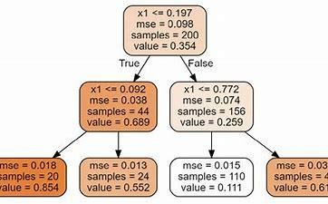

# Model Evaluation:

The confusion matrix, accuracy score, precision, recall, sensitivity, and Fl score are employed in the evaluation procedure. [13]A confusion matrix is a table-like structure with true positive and true negative values. It is divided into four parts: the first is true positive (TP), in which the values are labelled as true and, in reality, they were also true. The second kind is false positive (FP), in which the values found are false but are recognised as true. The third type is false negative (FN), in which the value was true but was misidentified as negative. The following terms are used: score, precision, recall, sensitivity, and Fl score. The fourth kind is true negative (TN), in which the value was actually determined as negative. Figure 8 depicts the table. In the diagram, P denotes positive, N denotes negative, TP denotes true positive, FN denotes false negative, FP denotes false positive, and TN denotes true negative. An accuracy score is then used to determine how well a model performs. It is defined as the sum of true positive and true negative values divided by the sum of true positive and true negative + false positive and false negative. The equation is

Following accuracy is specificity, which is the fraction of real negative instances labelled as negative; consequently, it is a measure of how successfully a classifier recognises negative situations. [14]It is often referred to as the genuine negative rate. The equation is

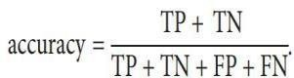

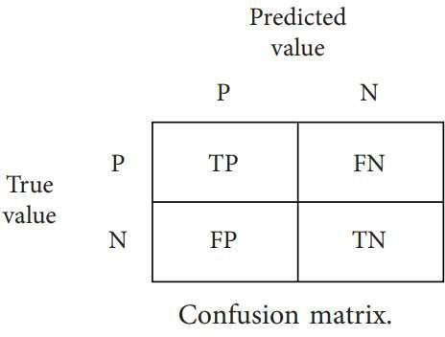

* 1. **RESULT ANALYSIS:**

After applying all the algorithms, we predicted the image. As shown in below figure we are predicting the happy or sad face by the help of image. By the help of supervised learning algorithm in which we the accuracy of linear regression, lasso regression, svc, random forest classifier, random forest,desion tree

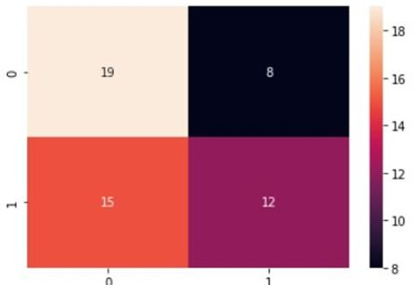

Fig Linear Regression Confusion Matrix

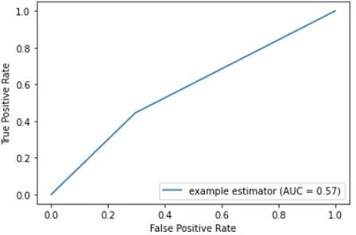

Fig Roc Curve for Linear Regression

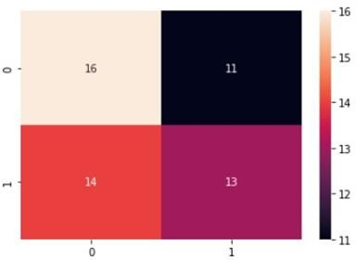

Fig Random Forest Confusion Matrix

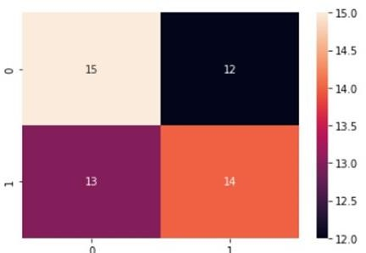

Fig Decision Tree Matrix

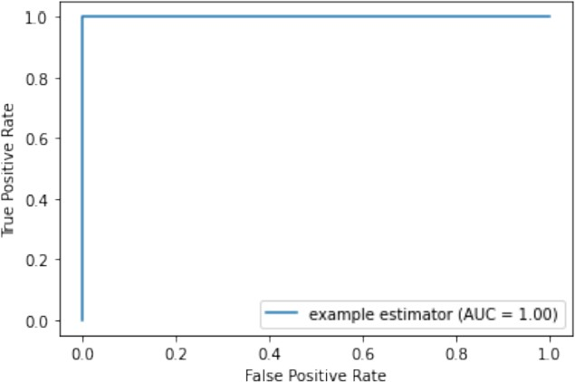

**So we successfully predicted the image that this image is having the sad sentiment because the sad has more accuracy than happy.**

1. 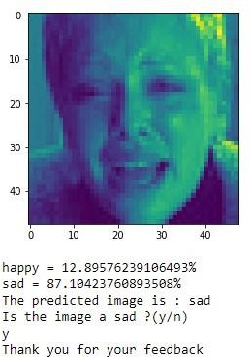**CONCLUSIONS**

Numerous studies and investigations on Emotion Recognition, Deep Learning methods utilised for emotion recognition are being undertaken. It will be necessary in the future to create a model like this that is far more trustworthy and has endless potential in all disciplines. This project attempted to solve the emotion recognition problem using inception net. Many different types of data are required to anticipate this sort of emotion. [15]In this work, I proposed all potential algorithms that might be used in emotion recognition.

1. **Future scope:**

When the deep learning comes here it will be more easilydone by help of algorithm Further research lines could focus on the development of new metrics and dimensions for emotion assessment and classification of complex emotions.



# Amity University Madhya Pradesh

**10** I **April 2021**

1. **REFERENCES**
2. M. El Ayaadi, F. Karraeand M. S. Kamal “Survey on emotion recognitions: Features, classification scheme, and database,” Pattern Recognit., vol. 44, no. 3, pp. 572– 587, 2011.
3. Y. Lecan, Y. Bengeo, and G. Hintin, “Deep learning,” Nature, vol. 521, no. 7553, pp. 436–444, 2015. [3] J. Schmidhubar, “Deep Learning in neural networks: An overview,” Neural Networks, vol. 61, pp. 85– 117, 2015.
4. Ngiem, A. Khoslaa, M. Kam, J. Nim,

H. Lei, and A. Y. Nig, "Multimodal Deep Learning," Proceedings of the 28th International Conference on Machine Learning, pp. 689–696, 2011.

1. S. Lugivic M. Harva and I. Dander “Techniques and applications of emotion recognition,” 2016 39th Int. Conv. Inf. Commun. Technol. Electron. Microelectron. MIPRO 2016 - Proc., no. November 2017, pp. 1278–1283, 2016.
2. B. Schaller, G. Rigull, and M. Ling, “Emotion recognition combining acoustic features and information in a neural network - belief network architecture,” Acoust. Speech, Signal Process., vol. 1, pp. 577–580, 2004.
3. J. Riang, G. Leie, and Y. P. P. Chen, “Acoustic feature selection for automatic emotion recognition from speech,” Inf. Process. Manag., vol. 45, no. 3, pp. 315–328, 2009.
4. F. Noruzi, G. Anbarjafaari and N. Akraami “Expression-based emotion recognition and next reaction prediction,” 2017 25th Signal Process. Commun. Appl. Conf. SIU 2017, no. 1, 2017.
5. G. Hintin ,Greves and A. Mohemed, “Emotion Recognition with Deep Recurrent Neural Networks,” in 2013 IEEE International Conference on Acoustics, Speech and Signal Processing, 2013,

[10] pp. 6645–6649. 10. K.Weint and C.-W.

Huaang,

“Characterizing Types of Convolution in Deep Convolutional Recurrent Neural Networks for Robust M.

1. Eldar, C. Yonina, Compressed sensing: theory and applications, Cambridge University, 2012.
2. Solomon, Chris, Fundamentals of Digital Image Processing: A practical approach with examples in Matlab. John Wiley & Sons, 2011.
3. Parkhi, Omkar M., Andrea Vedaldi, and Andrew Zisserman. "Deep face recognition." In bmvc, vol. 1, no. 3, p. 6. 2015.
4. Grafsgaard, Joseph, Joseph B. Wiggins. "Automatically recognizing facial expression: Predicting engagement and frustration." In Educational Data Mining 2013.
5. Moridis, Christos N., and Anastasios. "Affective learning: Empathetic agents with emotional facial and tone of voice expressions." IEEE Transactions on Affective Computing, vol. 3, pp. 260-272,2012.